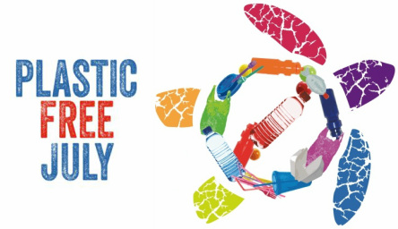
At school we are having a Plastic Free Week as part of our involvement in ‘Plastic Free July’. Week 2 of this term our school will be taking a closer look, during class eating time, at what is in our lunch boxes in regards to plastic use. Students are asked to try hard to reduce the amount of plastic waste they use and look at alternatives during this week.
We are also extending the challenge out to you at home. The challenge is quite simple. Attempt to consume no single-use plastic during July. "Single-use" includes plastic shopping bags, plastic cups, straws, plastic packaging...basically anything that's intended only to be used once and then sent to landfill. If refusing ALL single-use plastic sounds too daunting this time, try the TOP 4 challenge (straws, plastic bags, plastic bottles &coffee cup lids). Remember it's not going to be easy! It is a challenge, not a competition so don't worry about being perfect and it's up to you regarding how long you participate. You might decide to go plastic-free for a day, a week, a month or longer! However long you choose will still make a contribution.

Why you should participate
•Australians send 1 million tonnes of plastic waste to landfill each year. Do your part to make a change.
•Why use something for a few seconds that is going to spend the rest of your life trying to break down in landfill? We really need to change our habits.
All the best with your challenge of making a difference to landfill. If you would like any more information head to http://www.plasticfreejuly.org/ or visit the link on the school’s web site.
Kind Regards
Lorell Masters

