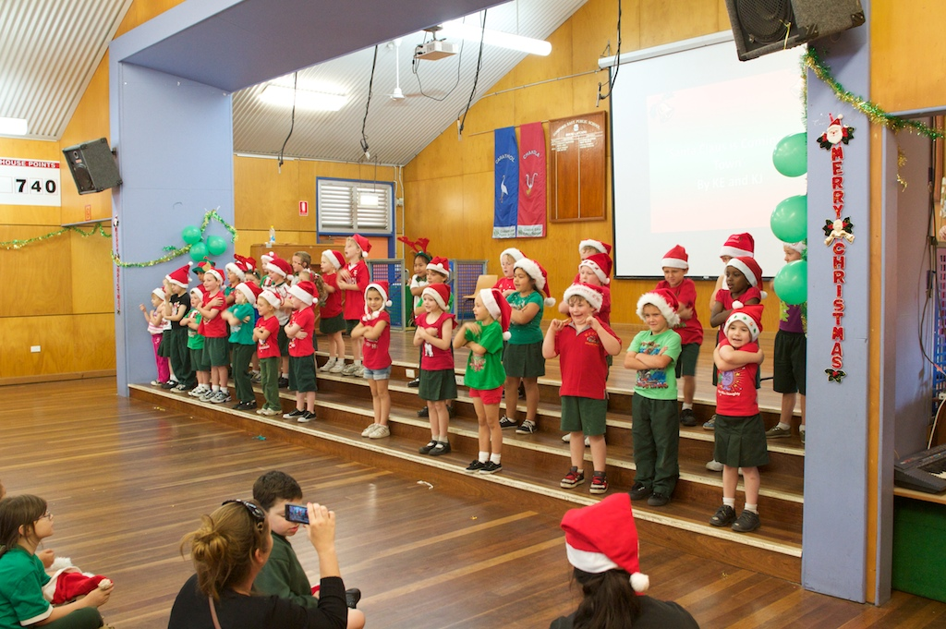

4218

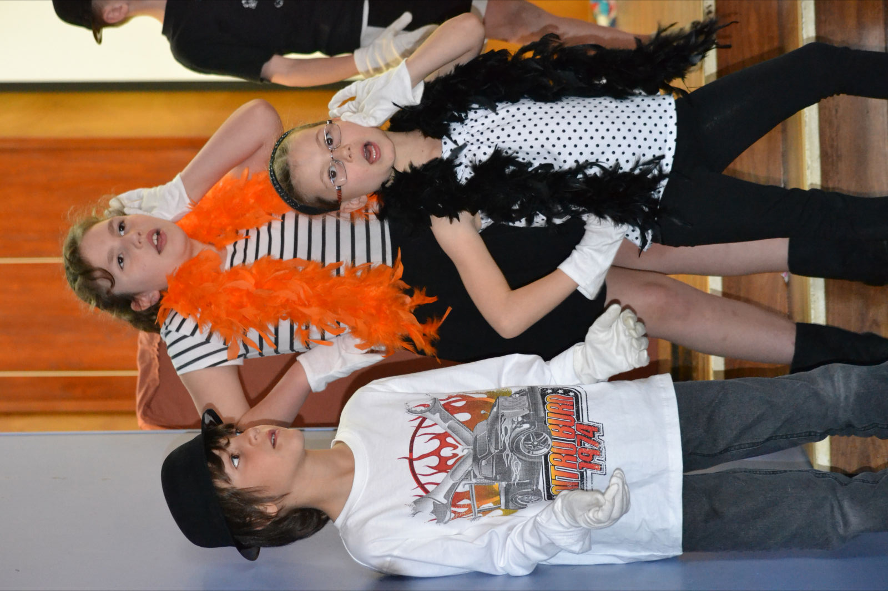

Gosford East Public School

Annual School Report

20111

Our school at a glance

Students

Our enrolment in 2011 was 295, comprising of 157 boys and 138 girls. There were fourteen classes in the school which included three support classes: two for students with physical disabilities and one for students with mild intellectual disabilities. We have fewer girls than boys.

Staff

The school has 20 teaching staff which includes: 4 Assistant Principals and 10 classroom teachers. Other support staff includes 1 District Guidance Officer who coordinates School Counsellors across a number of schools. In addition, we have a School Administrative Manager, a School Administrative Officer, a School Assistant one day a week in library, a General Assistant for two days per week and three School Learning Support Officers who support our Support Classes. There was also a School Learning Support Officer to assist students with special needs in classrooms across the school.

Details are provided on page 3.

All teaching staff meet the professional requirements for teaching in NSW public schools.

Significant programs and initiatives

The school ran a number of programs and initiatives to enhance the learning experiences and educational outcomes of our students. These included:

* Values Education, Bullying, Child Protection and Drug Education programs;
* Personalised Learning Plans for Aboriginal Students and Aboriginal Education Programs;
* Literacy Programs for students with “Low Support Needs”;
* Computer Education;
* Evaluation of our English Policy;
* Leadership in the Middle School;
* School Choir.

Student achievement in 2011

**Literacy – NAPLAN Year 3**

Our results in Year 3 Literacy were most pleasing being above state average in Reading and Writing, just below in Spelling and Grammar and Punctuation. We were above the Similar School Group (SSG) in all areas which was most pleasing.

**Numeracy – NAPLAN Year 3**

Our results in Numeracy were most pleasing, we were 18 points above state average in both areas, with 47% being in the top two bands with no student in Band 1.

**Literacy – NAPLAN Year 5**

We were mixed results with our Year 5. We were above state average in Reading and Grammar and Punctuation and below in Writing and Spelling. Boys did better than girls in all areas.

**Numeracy – NAPLAN Year 5**

Our Numeracy results were again pleasing. Our school average was around state average in all areas.

Messages

Principal’s message

Gosford East Public School continues to provide a sound education where students are encouraged to do their personal best in a very supportive and nurturing environment. We continue to place an emphasis on the basics while still placing importance on the development of values and skills for life.

We do have a very diverse student population with varying needs that are catered for by very professional teaching and support staff.

Parent and community support continues to be very high. Bunnings have built and landscaped three raised garden beds and provided plants for these.

The P & C continue to be extremely supportive and provide many resources for the school. This year they purchased six computers and provided $3000 for literacy resources. They also run the Uniform Shop, School Banking, Bookclub, Mothers and Fathers Day stall and the Canteen which ensure that the children can be clothed and fed at very reasonable prices.

Local sporting clubs continue to provide programs for the children at our school and the links with the business community continue to be very strong. Without their support the school could not deliver all that is expected.

I certify that the information in this report is the result of a rigorous school self-evaluation process and is a balanced and genuine account of the school’s achievements and areas for development.

Graeme McLeod

P & C 2011 Presidents Report

2011 has been another successful year for Gosford East Public Schools P&C. With a bit more experience this year we have continued to raise money for our wonderful school and provide it with those little extras that help both students and teachers.

In 2011 we didn’t have a major event but we still managed to hold 3 discos, Mothers and Fathers day stalls, and Election BBQ. We also raised money thorough our School Canteen, Uniform Shop, Scholastic book club and Commonwealth school banking program. The money raised throughout 2011 was donated back to the school with $3000 going towards new computers and another $3000 towards school books.

In 2012 we hope to again have a few new members to help our school. We also hope to raise enough money to restore our gardens back to their former beauty.

Thanks again to our magnificent committee for the past year. All of you help hasn’t gone unnoticed. Thanks also to all the mums who can’t commit to full time P&C but came and helped with stalls, school banking, book club, uniform shop and canteen. Hope you are looking forward to another great year.

**Nyssa Van Dam**

**P & C President**

Student information

It is a requirement that the reporting of information for all students must be consistent with privacy and personal information policies.

Student enrolment profile

|  |  |  |  |  |  |
| --- | --- | --- | --- | --- | --- |
| **Gender** | **2007** | **2008** | **2009** | **2010** | **2011** |
| **Male** | 200 | 188 | 179 | 163 | 157 |
| **Female** | 128 | 144 | 139 | 141 | 138 |

Our enrolments continue to decline with a lower than usual kindergarten enrolment anticipated in 2012.

Student attendance profile

|  |  |  |  |  |  |
| --- | --- | --- | --- | --- | --- |
| **School** | **Year** | **2008** | **2009** | **2010** | **2011** |
| K |  | 96.3 | 95.9 | 95.3 |
| 1 |  | 92.5 | 95.4 | 94.1 |
| 2 |  | 94.6 | 92.5 | 95.8 |
| 3 |  | 93.6 | 93.4 | 94.4 |
| 4 |  | 94.7 | 94.9 | 92.3 |
| 5 |  | 94.8 | 95.0 | 93.7 |
| 6 |  | 93.6 | 94.7 | 96.1 |
| **Total** | **93.8** | **93.9** | **94.6** | **94.6** |
| **Region** | K |  | 94.3 | 94.6 | 94.7 |
| 1 |  | 93.6 | 93.9 | 93.9 |
| 2 |  | 93.7 | 94.0 | 94.0 |
| 3 |  | 93.7 | 94.0 | 93.8 |
| 4 |  | 93.5 | 93.9 | 93.9 |
| 5 |  | 93.4 | 93.7 | 93.6 |
| 6 |  | 93.0 | 93.3 | 93.2 |
| **Total** | **93.7** | **91.5** | **93.9** | **93.9** |
| **State DEC** | K |  | 94.3 | 94.7 | 94.7 |
| 1 |  | 93.7 | 94.2 | 94.2 |
| 2 |  | 94.0 | 94.4 | 94.2 |
| 3 |  | 94.1 | 94.5 | 94.4 |
| 4 |  | 94.0 | 94.5 | 94.3 |
| 5 |  | 94.0 | 94.4 | 94.2 |
| 6 |  | 93.6 | 94.0 | 93.8 |
| **Total** | **94.1** | **92.1** | **94.4** | **94.3** |

Our attendance rate was higher than Regional State average which is most pleasing.

Management of non-attendance

The school has an active Attendance Plan which outlines strategies that are to be carried out should a child have significant absences. This also outlines the roles of staff and parents in assisting to improve attendance.

Class sizes

Primary class sizes are included in the annual school report in order to provide parents with as much local information as possible. The following table shows our class sizes as reported at the 2011 Class Size Audit conducted on Monday 21 March 2011.

|  |  |  |  |
| --- | --- | --- | --- |
| **Roll class** | **Year** | **Total per year** | **Total In class** |
| KE | K | 18 | 18 |
| KJ | K | 19 | 19 |
| 1FM | 1 | 22 | 22 |
| 1K | 1 | 23 | 23 |
| 2R | 2 | 21 | 21 |
| 2T | 2 | 24 | 24 |
| 3-4B | 3 | 9 | 29 |
| 3A | 3 | 28 | 28 |
| 3-4B | 4 | 20 | 29 |
| 4-5S | 4 | 16 | 29 |
| 4-5S | 5 | 13 | 29 |
| 5-6E | 5 | 11 | 31 |
| 5-6W | 5 | 10 | 31 |
| 5-6E | 6 | 20 | 31 |
| 5-6W | 6 | 21 | 31 |
|  |  |  |  |

Structure of classes

This year we have three Support Classes, 7 “straight” grade classes and 4 multi grade classes.

Staff information

It is a requirement that the reporting of information for all staff must be consistent with privacy and personal information policies.

Staff establishment

|  |  |
| --- | --- |
| Position | Number |
| **Principal** | 1 |
| **Assistant Principal(s)** | 4 |
| **Head Teachers/ District Guidance Officer** | 1 |
| **Classroom Teachers** | 8 |
| **Teacher of Physical Disabilities** | 1 |
| **Teacher of Mild Intellectual Disabilities** | 1 |
| **Teacher of Reading Recovery** | .4 |
| **Support Teacher Learning Assistance** | .6 |
| **Teacher Librarian** | .6 |
| **Teacher of ESL** | .2 |
| **Counsellor** | 1 |
| **School Administrative & Support Staff** | 5.2 |
| **Total** | 24 |

The National Education Agreement requires schools to report on Indigenous composition of their workforce.

[Enter a statement describing the Indigenous composition of the school workforce. Principals are strongly advised to refer to the Support Document for further information.]

Staff retention

One teacher has received a transfer to another school.

Teacher qualifications

All teaching staff meet the professional requirements for teaching in NSW public schools.

[Enter text here.]

|  |  |
| --- | --- |
| Qualifications | % of staff |
| Degree or Diploma | 100 |
| Postgraduate | 20 |

Financial summary

This summary covers funds for operating costs and does not involve expenditure areas such as permanent salaries, building and major maintenance.

A full copy of the school’s 2011 financial statement is tabled at the annual general meetings of the parent body. Further details concerning the statement can be obtained by contacting the school.

|  |  |
| --- | --- |
| Date of financial summary: | 30/11/2011 |
| ***Income*** | **$** |
|  |  |
| Balance brought forward | 201 556.68 |
| Global funds | 193 523.47 |
| Tied funds | 125 569.58 |
| School & community sources | 73 321.94 |
| Interest | 12 299.77 |
| Trust receipts | 6 243.40 |
| Canteen | 0.00 |
| *Total income* | *612 514.84* |
|  |  |
| ***Expenditure*** |  |
| Teaching & learning |  |
| Key learning areas | 33 252.50 |
| Excursions | 27 108.71 |
| Extracurricular dissections | 21 301.23 |
| Library | 6 705.19 |
| Training & development | 857.65 |
| Tied funds | 130 028.77 |
| Casual relief teachers | 71 551.65 |
| Administration & office | 33 734.80 |
| School-operated canteen | 0.00 |
| Utilities | 44 030.32 |
| Maintenance | 8 035.92 |
| Trust accounts | 5 406.14 |
| Capital programs | 0.00 |
| *Total expenditure* | *382 012.88* |
| **Balance carried forward** | **230 501.96** |
|  |  |

School performance 2011

Achievements

Arts

During 2011 Gosford East participated in a wide range of activities in Creative and Practical Arts (CAPA) including:

* Weekly assemblies, where completed work was presented to or performed for the school community;
* The students attended a number of performances at the school;
* Art work is displayed each week by different classes by each stage;
* Some of our Aboriginal students displayed their work at the Regional Art Gallery;

The Choir under the leadership of Christie Trigg continues to be very successful performing at Erina Fair and local aged care facilities and school functions. About 80 students are in the choir which is nearly a third of the school.

Sport

Gosford East Public School has again had a successful year in sport. Although our school is dropping numbers we are still able to compete favourably with other schools. The behaviour and sportsmanship displayed by our students on any sporting field has been outstanding.

The first major event of 2011 was the Swimming Carnival. The most special moment occurred when at the district carnival Ben Kemsley swam in an event for students with disabilities. This was the first time an event has been held at the district level. It was heart warming to see the entire stadium stand and cheer as he completed his event. This has started a tradition with other disabled athletes from other schools competing at the district athletics. It was mentioned at the BWPSSA meeting recently.

Our cricket team was played an exceptional game against a much larger school. Although they lost the match they all played very well.

Our soccer teams were coached by Ms Sansom. The boys team won two games out of the three and worked well as a team. The girls first game against Lisarow was a great game with all the girls showing great spirit and they did not have an opposition for their second game.

The boys and girls basketball teams were organised by Mr Whelan and coached on the day by Mrs Flynn. The captains Julia and Dylan displayed excellent leadership skills, encouraging all players throughout the day.

Our AFL teams were also competitive on our Paul Kelly Cup day. The boys played well, making it to the semi-finals. The girls competed gallantly against teams mainly made up of boys. A great day was had by all.

Many students also participated in the Learn to Swim classes down at Gosford Pool. The behaviour and attention to lessons from our students is to be commended. Our students are always very sensible when they have to walk long a busy road when going to the pool.

Our support unit again had a successful year.

The Cross Country and Athletics Carnival were also a great success.

The school has been able to increase its amount of sporting equipment over the years and now has a large amount of valuable learning tools for teachers or simply for fun objects such as Frisbees and Vortex for the students to enjoy. We have also purchased a new set of sports jerseys designed by Owen and Sophie. The P & C organised some sponsorship for these and they paid for the remainder.

Without the amount of parent support our sporting program would not happen. Parents assist with transporting, scoring, coaching, managing, washing jumpers, photo taking and generally support our students.

Our sports captains this year have done an excellent job especially at carnival time. Many students have also assisted by handing out sporting gear at lunch time and recess and getting sporting gear ready for teachers for sports afternoons.

Academic

In the National Assessment Program, the results across the Years 3, 5, 7 and 9 literacy and numeracy assessments are reported on a scale from Band 1 to Band 10.

The achievement scale represents increasing levels of skills and understandings demonstrated in these assessments.

Yr 3: from Band 1 (lowest) to Band 6 (highest for Year 3)

Yr 5: from Band 3 (lowest) to Band 8 (highest for Year 5)

Literacy – NAPLAN Year 3



The number of students in the three highest bands is higher than the 2008- 2011 average which is most pleasing. We also had very few students in the bottom two bands which is also most pleasing.



We were above average in the top three bands and had very few students in Band 2 with no student in Band 1 which is extremely pleasing.



Although we had above state average in the number of students in the top three bands we are slightly underrepresented in the top two bands. It was pleasing to see that we have less numbers than average in the bottom two bands. Our average score was just below state average.



Our school average score was just above like school average and 12 points below state average. As with Spelling we had fewer students in Band 6 than the rest of the state but above average in the top three bands. It was pleasing to note that we had fewer than our like schools or state average in the lower three bands.

Numeracy – NAPLAN Year 3



As can be seen the percentage of students in the top two bands is above state and regional average. The school had 47.2 % of students in the top two bands compared with 36.4% of the state and 31.4% of similar schools to us. It was most pleasing that there were no students in Band 1.

Literacy – NAPLAN Year 5



Although we had higher than state average in the top three bands we had a lower than average in the top two bands. We had around state average in the bottom two bands.



Although we had just below the state average score it was disappointing that we did not have any students in Band 8. This will be one of our priority areas for 2012.



It was disappointing that our average score was 4 points below similar schools and 14 points below state average. Although we had more than average in Band 7 we were underrepresented in Band 8. Spelling will be a focus area next year.



It was most pleasing that we had more than the state average in the top band and more than similar schools in the top three bands. Our average score was also higher than the state average.

Numeracy – NAPLAN Year 5



It was again pleasing that we were above state and SSG average in the top three bands and only a few in the bottom two bands. Our average score was also above state average which was most pleasing.

Progress in literacy

|  |  |  |
| --- | --- | --- |
| **Average progress in Reading** | | |
| **between Year 3 and 5\*** | | |
|  | **2008-2010** | **2009-2011** |
| **School** | 106.4 | 98.2 |
| **SSG** | 83.5 | 75.9 |
| **State DEC** | 83.7 | 74.0 |

71.9% of our students reached expected growth in Reading, with our average growth being 24 points above state average.

|  |  |  |
| --- | --- | --- |
| **Average progress in Spelling** | | |
| **between Year 3 and 5\*** | | |
|  | **2008-2010** | **2009-2011** |
| **School** | 86.1 | 81.2 |
| **SSG** | 85.4 | 74.6 |
| **State DEC** | 84.5 | 75.4 |

65.6% of our students reached expected growth in Spelling, with our average growth being 6 points above state average.

|  |  |  |
| --- | --- | --- |
| **Average progress in Grammar & Punctuation between Year 3 and 5\*** | | |
|
|  | **2008-2010** | **2009-2011** |
| **School** | 146.9 | 94.8 |
| **SSG** | 93.2 | 78.2 |
| **State DEC** | 96.6 | 82.7 |

65.6% of our students reached expected growth in Grammar & Punctuation, with our average growth being 12 points above state average.

Progress in numeracy

|  |  |  |
| --- | --- | --- |
| **Average progress in Numeracy** | | |
| **between Year 3 and 5\*** | | |
|  | **2008-2010** | **2009-2011** |
| **School** | 114.0 | 104.1 |
| **SSG** | 86.2 | 94.1 |
| **State DEC** | 89.6 | 95.8 |

65.6% of our students reached expected growth in Numeracy, with our average growth being 8 points above state average.

Minimum standards

The Commonwealth Government sets minimum standards for reading, writing, grammar and punctuation, spelling and numeracy for Years 3, 5, 7 and 9.

The performance of the students in our school in the National Assessment Program – Literacy and Numeracy is compared to these minimum standards. The percentages of our students achieving at or above these standards are reported below.





Significant programs and initiatives

Aboriginal education

Aboriginal history and culture is valued across our school.    
This year, classroom programs included Aboriginal perspectives across the curriculum particularly in the English and Human, Society and Environment areas.

Early Stage One classes studied Aboriginal Literature. One class looked at Aboriginal Festivals during their HSIE Unit on Celebrations.

Personalised Learning Plans

In Term 1, the Learning Support Team (LST) organised meetings with Aboriginal parents and caregivers to develop a Personalised Learning Plan (PLP) for each student. All of the students also attended these meetings and spoke about their interests, goals and academic areas needing support. Identified students across the school were supported with literacy and numeracy programs including the: Reading Recovery, Support Teacher-Learning Assistance (STLA) and Relief from Face-to-Face (RFF) programs. The result of this coordinated approach was an improvement in skills for all of the students. For the first time in a long time, almost all of our current group of Aboriginal students are reading at or above their grade level.

Reconciliation Week

In Term 2, every class in the school either interviewed a local Aboriginal elder or they read about a nationally well-known Aboriginal person.  Then, they wrote a factual biographical recount for display as part of our annual Reconciliation Week celebrations.  Stage 1 students read about Aboriginal sports people or entertainers and Stage 2 & 3 students read about Aboriginal community activists or politicians.  We were very lucky to able to interview Aboriginal elders Auntie Anita Selwyn and Keith Hall from the local community.  Examples of the best writing were displayed on the walls of the Hall along with portraits and posters.  Later, these were collated and published in a magazine.  Once again, teachers and students demonstrated great creativity and ingenuity.

Our Reconciliation Week Assembly was a big event.  Auntie Anita Selwyn gave the Welcome to Country.  Class 2R danced to the Warumpi Band’s “Whitefella-Blackfella” and some of our Aboriginal students presented their biography writing to Auntie Anita in the form of a “This Is Your Life” summary. Two high school students, who travelled on this year’s Youth Connections Freedom Ride Trip, gave a PowerPoint presentation about the trip and Charlie Perkins.  Some Aboriginal students from Woodport P.S. also attended as part of the audience.

Other Special Aboriginal Cultural Events:

In late March, the Aboriginal Education Consultative Group held their meeting in our library.

In mid August, approximately 20 GEPS Year 6 students attended a NAIDOC Week Transition Program Day at Erina High School where there were Aboriginal Cultural Workshops on Art, Dance, Boomerang Throwing, and Bush Tucker.

Multicultural education

We have again had the services of an ESL teacher at our school for one and day per week. She also acts as a mentor for other ESL teachers across the region. The number of ESL children at our school continues to grow. Multicultural aspects continue to be taught across the curriculum and the school celebrates significant days and events.

This year Harmony Day was one of the key aspects of our calendar where we recognised the diversity of cultures in Australian society.

Respect and responsibility

Respect and responsibility continue to be the key aspects of the ethos of the school. The teaching of these expectations is both integrated throughout the curriculum and taught explicitly.

Each stage teaches a program of work where all areas contained in the NSW Values statement are covered.

The staff and students have reviewed and further developed key values that underpin our School Welfare System.

Other programs

**Support Classes**

Our 3 Support Classes (1 x IM, 2 x P) continue to provide individual and group programs to meet the special educational, physical and social needs of students within the context of a mainstream primary school setting.

Use of computer technology is a feature of teaching and learning programs.

Our students are well supported by our on site Northern Sydney Central Coast Health Team with individual intervention and in-class programs.

Special off site programs included weekly swimming, gym and horse riding, for students with a physical disability, and Special Swim School.

Our students enjoy full participation in whole school activities.

Progress on 2011 targets

Target 1

**To improve comprehension and spelling skills of all students**

Our achievements include:

* Review scope and sequence of reading and spelling;
* Provided Training and Development of specific teaching strategies including “Super 6” and “STARS” program for comprehension;
* Implemented CARS assessments for comprehension and 1 minute read benchmarks for Grade 2-6;
* Purchased relevant resources including new “readers” for the teaching of reading and comprehension and teacher resources to support comprehension and spelling;
* We were 10 points above state average and 17 points above similar schools in reading in Year 3 and 4 points above similar school average and just below state average in Spelling in Year 3;
* We were also above state and similar school average in Reading but below state average by 13 points in spelling;
* Our average progress between Years 3 and 5 in Reading in the NAPLAN tests was 98.2 points which was 24 points above state average;
* Our average progress in spelling was 81.2 points which was 6 points above state average.

Target 2

**To improve the numeracy skills of all students.**

Our achievements include:

* Staff use SMART package to inform programming and individual student support;
* Reviewed scope and sequence to ensure all aspects of the curriculum are being taught and that this is reflected in teachers programs;
* Purchased relevant resources and provided training and development for staff;
* We were 19 points above state average and 29 points above similar school average in Year 3 and 3 points above state and 13 points above state average in the Numeracy NAPLAN test;
* 47% of Year 3 students achieved a Band 5 or 6 in the NAPLAN;
* 26% of Year 5 students achieved a Band 7 or 8 in the NAPLAN test;
* Our average progress in the NAPLAN tests between Years 3 and 5 was 104 points which was 9 points above state average.

Target 3

**The school will exceed regional literacy targets in Early Stage 1 and Stage 1.**

Our achievements include:

* There has been ongoing support and resourcing of the Best Start program;
* Teacher professional development in Best Start has been provided for all Early Stage 1 and Stage 1 teachers;
* There has been an emphasis on the ongoing benchmarking of students;
* Best Start has been implemented and students in need of additional support have been identified. We have provided parents with strategies to work with the school so to achieve the best outcomes for their children;
* 88% of children in Early Stage 1 have reached the regional literacy benchmark;
* 75% of children in Year 1 have reached the regional literacy benchmark;
* 64% of children in Year 2 have reached the regional literacy benchmark.

Key evaluations

It is a requirement for all NSW public schools to conduct at least two annual evaluations – one related to educational and management practice and the other related to curriculum. In 2011 our school carried out evaluations of the following:

**Parent Teachers Interviews**

Background

Assessment and reporting is an integral part of teaching and learning. Our school reports student achievement in a number of ways including, 2 formal written reports and at least 1 face to face interview is offered to all parents. The school decided to survey parents directly following the mid year interviews. Sixty six surveys were sent home with 29 being returned.

Findings and conclusions

Nearly all parents that returned their surveys were very positive across most areas which was extremely pleasing. All parents said that the parent /teacher interviews were what they expected or greater, with 40% saying that it was better than they expected. All but two parents stated that communication with the teacher was extremely or very important with two parents stating that it was moderately important. 97% of parents were extremely or very satisfied with the information provided at the interview in regard to their achievements.

Although most people said that the interview was important to them in helping them to understand their child’s report 8% said it was only moderately important and 1 parent said it was not important at all.

The comments provided by parents included that the interviews communicated very well to parents the areas that a child needed to improve, that they were very well organized and that the feedback was very positive and that teachers were aware of their child’s strengths and weaknesses.

The responses to the questions in regard to what could we do to improve the interview process or communication with parents there was a wide range of responses. These included “teacher comments are great but report ranking is silly”, for some children the 15 minutes allocated is not long enough, that teachers were open and honest and that we should hold night time interviews so working parents can get there.

Future directions

We were extremely happy with the feedback provided and were heartened by the many positive comments. We will communicate to parents at parent teacher information sessions and in the newsletter that parent interviews can be held throughout the year not just during the report writing period. It will also be communicated that parents or teachers can request a longer interview if there are complex issues or a lot to discuss.

Curriculum

English

Background

An evaluation of English was conducted by the school improvement committee. For parents we asked question about all areas of literacy and for teachers we had a general survey and then another that focused on writing and spelling.

Findings and Conclusions

We had quite a good response rate from parents with 44 out of 55 surveys returned. The responses from parents were mostly very positive. As was expected all parents believed that Literacy was important for their child and that there was good access to technology.

All but one parent believed that their child has improved in Reading, Writing and Spelling and most stated that their child enjoyed English/ Literacy. Two parents were unsure whether their child enjoyed Literacy and 3 stated that their child did not like English.

All but one parent said that the reports that they were provided with supplied useful information and that home reading was a valuable part of their child’s learning.

27 of the 44 parents said that would be interested in training to assist them with Reading. It was somewhat of a concern that 6 children do not read at home. Some parents stated that it was often difficult to read with their child every night due to sports and other commitments.

14 teachers returned the general English survey. All teachers had a copy of the syllabus, used it to develop their classroom programs and stated that they enjoyed teaching English.

7 teachers (50%) said that they were only somewhat confident of using NAPLAN data to inform planning.

11 staff stated that they would like further training in the teaching of English and in using the Smartboard to reinforce their Programs.

Only 6 teachers said that they used the schools scope and sequence and 4 said that the home readers were suitable for their students. 5 teachers said that they sometimes have difficulty in assessment of English.

In the writing survey all teachers believed that their students improved with their writing and most said that they always tell their students the purpose of their writing and that their teaching of Writing had improved last year.

All teachers would like further training in the teaching of Spelling. They all state that they teach spelling in an explicit manner and that they have developed strategies to teach unknown words.

Most teachers state that they enjoy using Spelling Conventions as a support document and that their students enjoy using it. However most state that this textbook does not fulfil the needs of all students eg. GATS, ESL, LD.

Future Directions

The Literacy Committee will further examine parent needs in regard to further training and where possible provide this for parents. They will also examine the current scope and sequence in all areas of the English Curriculum and redesign these so that they fulfil the needs of teachers and the curriculum. The new syllabus will be taken into consideration in this development.

The English Committee will also look at further training for staff in Spelling and Writing and work with our technology team to look at further training in the use of the Smartboard.

The executive will provide support for teachers in the use of SMART data to inform their programming.

The English Committee will also further survey the staff to determine more comprehensively their training needs in relation to Comprehension and Spelling.

Parent, student and teacher satisfaction

In 2011 the school sought the opinions of parents, students and teachers about the school.

Their responses are presented below.

The parent survey again came back very positive. Out of 50 surveys handed out, 31 were returned. These were overall very positive with most responses being in the Strongly Agree or Agree rating.

The most positive responses were that the school office responds to enquiries and requests in a friendly manner, the school promotes core values, has competent teachers, the school is a friendly school that is tolerant and accepting of all students, the students are the school’s main concern, the school has supportive welfare programs and that the weekly newsletter keeps the community informed of ongoing events and important issues.

It was pleasing to note that the community believed we are improving in the area of technology. Nearly all believed that the new building works would be beneficial to the school. There were two parents that had a number of negative responses in a number of areas including fair discipline does not exist within the school, my child enjoys going to school each day and that the school is a friendly place.

In 2012 we will ensure that we communicate our complaints policy to our parents so they have a better understanding of how it operates and supports students, teachers and families.

Students from Years 3-6 completed the survey online. The student’s responses were extremely positive especially in the area of technology. Students again believed that the Smartboards were helping them learn and that teachers used them well in class. Nearly all students thought that the new extensions to the classrooms improved their learning environment.

Teachers again were positive overall in their responses, the main areas were technology and academic achievement. The teachers identified a number of areas that they would like further training and development in especially in the teaching of comprehension, spelling and grammar.

Professional learning

The school spent around $17,000 on professional learning in 2010, targeting literacy, numeracy, welfare and other aspects of teacher’s professional learning plans.

School planning 2012—2014

The school planning policy provides direction for the preparation and implementation of school plans including the identification of priority areas, intended outcomes and targets that are consistent with the NSW State Plan and the Department’s planning documents.

School priority 1

Outcome for 2012–2014

Increased level of numeracy achievement for every student in line with state plan and regional targets

2012 Targets to achieve this outcome include:

* To improve numeracy standards of all students in the Measurement, Data, Space and Geometry strands;
* To improve numeracy skills of all students such that the growth rate is an average of 95 points in the NAPLAN;
* To improve the number of Year 3 students in Bands 5 and 6 to 50%;
* To improve the number of students in Bands 7 and 8 to 30% in the numeracy areas of NAPLAN;
* To improve numeracy skills so that 75% of students achieve minimum growth in Numeracy.

Strategies to achieve these targets include:

* Staff to use SMART package to inform programming and individual student support;
* Review scope and sequence to ensure all aspects of the curriculum are being taught and that this is reflected in teachers programs;
* Provide relevant resources and training and development for staff.

School priority 2

Outcome for 2012–2014

Increased level of achievement of Stage outcomes in Literacy will be demonstrated by school based and NAPLAN data in line with state and regional targets

2012 Targets to achieve this outcome include:

* To improve writing skills of all students such that the growth rate is an average of 72 points in the NAPLAN and in reading (av. 90 points);
* To improve literacy skills so that 50% of students achieve minimum growth in writing and 80% in Reading;
* To improve the number of Year 3 students in Bands 5 and 6 to 40% in Reading and 40% in writing and 35% in spelling in the literacy areas of NAPLAN;
* To improve the number of Year 5 students in Bands 7 and 8 to 35% in Reading and 28% in writing ( with 10% in Band 8) and 10% in Band 8 in Spelling in the literacy areas of NAPLAN;
* 75% of all students in Early Stage 1 and Stage 1 achieve Regional Benchmark exit levels for Reading.

Strategies to achieve these targets include:

* Review scope and sequence of reading and spelling;
* Training and development of specific teaching strategies for guided reading, writing, comprehension and spelling;
* Provide relevant resources for the teaching of reading comprehension and spelling.

School Priority 3

Increased level of achievement of Early Stage 1 outcomes in Literacy and Numeracy will be demonstrated by school based and Best Start data in line with state and regional targets

2012 Targets to achieve this outcome include:

* 75% of children in Early Stage 1 will reach the

regional literacy benchmark;

* 75% of children in Year 1 will reach the regional literacy benchmark;
* 75% of children in Year 2 will reach the regional literacy benchmark.
* Increased level of achievement of Early Stage 1 outcomes in Literacy will be demonstrated by school based and Best Start data in line with state and regional targets

Strategies to achieve this target include:

* Ongoing support and resourcing of the Best Start program;
* Teacher professional development in Best Start for all Early Stage 1 and Stage 1 teachers;
* Ongoing benchmarking of students;
* Implementation of Best Start in Years 1 and 2;
* Purchase additional resources for Guided Reading and Numeracy.

About this report

In preparing this report, the self-evaluation committee has gathered information from evaluations conducted during the year and analysed other information about the school's practices and student learning outcomes. The self-evaluation committee and school planning committee have determined targets for the school's future development.

Graeme McLeod Principal.

Donna Ryan P & C Rep

Mark Emery Teacher Rep

Joanne Hextall Teacher Rep

School contact information

Gosford East Public School

Cnr. York and Webb Sts, East Gosford

Ph: 43252178

Fax: 43236930

Email: gosfordest-p.school@det.nsw.edu.au

Web: www.gosfordest-p.schools.nsw.edu.au

School Code: 4218

Parents can find out more information about Annual School Reports, how to interpret information in the reports and have the opportunity to provide feedback about these reports at:

<http://www.schools.nsw.edu.au/asr>